NATIONAL TRUST OF AUSTRALIA (VICTORIA)

NOMINATION FOR CLASSIFICATION

NAME
Saunders House

LOCATION:
90 Gatehouse Street, cnr Morrah Street, Parkville, Victoria. 3052, City of Melbourne

OTHER / FORMER NAMES

EXTENT
The whole building and the site

FILE NO
B5811

CATEGORY:
Private house

STATEMENT OF CULTURAL HERITAGE SIGNIFICANCE

What is significant?
The Saunders House on the corner of Gatehouse and Morrah Streets Parkville was designed by the architect-academic-historian David Saunders in1962 and completed in 1963.

David Saunders (1928–1986) was a seminal figure in the study of 19th century Australian architecture. A graduate of the Melbourne University Architecture course, in 1956 he became a lecturer there until 1968. It was during this period that he designed and built the Parkville house for his young family of wife and three (later four) daughters.

He was one of the first academics in Australia to actively research and appreciate 19th century architecture in Australia in the post war years. He was editor of the Historical Buildings of Victoria published in 1966 with the Victorian National Trust. He went on to become a leading figure in architectural education, particularly the establishment of architectural history as a discipline, at successively Melbourne University, University of Sydney and Adelaide University. He was also foundation president of the Australian branch of ICOMOS (International Council on Monuments and Sites) in 1976, and instrumental in founding Society of Architectural Historians, Australia and New Zealand (SAHANZ) in 1985.

The house is a simple rectangular structure with a roof form of opposing skillion roofs, and inset balconies on both front and rear elevations, referencing the terrace house context. The walls are dark grey concrete bricks, and the roof recycled slates. The Morrah Street façade features only a few small white painted timber framed windows and a central door. The east and west walls consist mainly of timber framed window-walls. The interior arrangement consists essentially of four rooms, with the kitchen / dining on the ground floor to the west, a spacious lounge down a few steps to the east, and the master bedroom and children’s bedrooms upstairs separated by the central timber dark stained timber stair and service rooms. The interior featured mainly exposed natural materials, such as the timber trusses of the bedroom roofs, the concrete of the lounge ceiling, and recycled brown ‘hawthorn’ bricks for internal linings throughout (many of these have since been painted or rendered over). With curtains as the room dividers, the house was originally quite open plan.

Why is it significant ?
The Saunders House is significant at the State level.

How is it significant ?
The Saunders House is significant as both one of the earliest expressions of the principles of the relatively new English ‘new brutalism’ architecture in Australia, and of an interest in referencing historic architectural forms and materials suitable to a 19th century Melbourne terrace house context. It was a singular design quite different from the architectural norms in Australia at the time, and pre-figured many design elements that would much later, in a modified form, become the norm.

The Saunders House is historically and socially significant as the self-designed home of one of Australia’s most eminent and influential architectural historians.

HISTORY

CONTEXTUAL HISTORY

David Saunders

Biography
(source www.sahanz.net/grants/saunders)

“David Saunders was educated at Royal Melbourne Institute of Technology and at the University of Melbourne where he also later completed his Masters degree on the architecture of 19th century Melbourne architect Joseph Reed. In 1956 he was appointed a Lecturer, then Senior Lecturer at the University of Melbourne where he remained until 1968. In that time, he became the first academic in Victoria to specialise in Australian architectural history.

Saunders was also editor of the pithy and incisive architecture broadsheet Cross Section, taking over from Robin Boyd as editor in 1955 then passing this task onto Neville Quarry in 1961. David Saunders was also an architect and in 1962 he designed his own house in Parkville after his return from the United Kingdom as part of a Nuffield Fellowship. The exposed materials and strident honesty of this post-war interpretation of the terrace house startled many and paralleled interstate experiments in English New Brutalism. In 1968 Saunders moved with his family to Sydney where he took up the position of Senior Lecturer at the Power Institute of Fine Arts at the University of Sydney. In 1977 he was then appointed to the Chair of Architecture at the University of Adelaide where took a decisive role in redirecting that school's curriculum.

David's contribution to architectural history in Australia was substantial. He was the author of several texts on Australian architecture including the important Historic Buildings of Victoria (1966). He gave substantial service to the National Trust and the South Australian Heritage Committee. He was also the first Australian President of ICOMOS, the international professional conservation organisation. David Saunders was instrumental in forming SAHANZ – the Society of Architectural Historians of Australia and New Zealand – and as foundation President he registered SAHANZ as an incorporated association in South Australia on 12th of September 1985. David Saunders was Professor of Architecture at the University of Adelaide and also President of SAHANZ when he died in Adelaide in September 1986.

As Judith Brine observed of David Saunders in his obituary in 1986:
"His career was one of dedicated service to the conviction that Australian art and architectural history was of great importance and interest. He not only demonstrated its academic potential in his own work but... provided the tools for others to work in the same field. His contribution as a teacher in training others, several of whom in their turn are now also eminent architectural historians, cannot be overestimated".

Activities in Victoria

Historic Buildings of Victoria was edited by Saunders, and published by the National Trust of Australia (Victoria) in 1966, the culmination of many years work. It was the first scholarly overview of the architectural heritage of this state, and clearly shows Saunders’ interest in the historic environment. This interest is also shown in collections of photographs now held at the State Library of Victoria; one is a set of photographs taken of every building in the Paris End of Collins Street in about 1956 (reportedly to be used by his students to generate drawings of the street), and another of Carlton and Parkville taken in about 1966 (including one of a block of Gatehouse Street, though not the one with his own house).

HISTORY OF PLACE

In 1962 David Saunders designed and had built this house at 90 Gatehouse Street Parkville to accommodate his family of six. The house was completed in 1963. Though there is to this day a Victorian–era cast-iron fence along the Gatehouse street frontage, MMBW maps show this site as without a building in 1897; it may have been the garden for the nearest house, being 86 Gatehouse Street.

The only review of the house at the time was printed in Architecture in Australia in June 1967, some time after the house was completed. In the text Neville Quarry provided for this article, he states that the site was one of the few vacant in Parkville.

By 1967 when the article was published, Saunders, in reply to Quarry at the end of the piece, notes that he was already considering changes to the interior, to provide separate spaces for his growing children, and noted that he was in fact pulling up the main bed (as intended) more days than he expected in order to use the room as a drawing office / studio. He also states that he was planning to paint the concrete ceiling of the living room “to dispel its tendency to gloom”.

It was reported that by 1999 most of the once bare brick and concrete surfaces had been rendered or painted. (Goad, Melbourne Architecture)

Influences

In the article, Quarry notes that the house was unique in Melbourne “in terms of serious un-imitative architecture”, and that “represents one of the first expressions in Australia … of an attitude… that Robin Boyd has lately termed the “third phase” of the modern movement.” He also related an anecdote that :

“Once when Reyner Banham dropped in to bounce his theories around a room full of architecture students (for whom David Saunders’ house was the only built hint they had of modern architecture apart from the slick and cosmetic) he remarked “But this is not an Australian house” which was an astute observation within the limits of his local experience to that date. What Banham had presumably noticed was the terse location of windows, the use of exposed brickwork throughout the interior walls, the off-form concrete slab ceiling and externally, the harsh silhouette; a not unusual combination in England, but rare, in Australia, in 1964.”

This is understood as a reference to the ‘Brutalist’ approach then taking hold in England, especially as practiced by Peter and Alison Smithson, championed by Banham. But Quarry goes on to state that this influence on his house was :

“… no pale dilution of images of the old New Brutalism, but on its own merits leapt to the vanguard of architectural development in Melbourne. So far in front in fact that there are still few local houses that look as though they may have been motivated by the same stream of ideas that influenced the Saunders’ house.”

It has been stated that the design of this house was strongly influenced by his direct experience of British ‘New Brutalist’ architecture obtained during his completion of a Nuffield Fellowship (year not stated but c1960).

However, as seen in the quotes from Quarry, it was no direct imitation (though the Sugden House by the Smithson’s of 1956 is one that certainly shows that avant-guard modernist architects could happily play with vernacular and traditional forms, even more so than the Saunders House).

Saunders himself does not discuss the influences behind his design in the article apart from the practicalities of the site, budget and needs. For instance, regulations at the time effectively prohibited the construction of ‘new’ terrace houses i.e. building to the side boundaries, so the house could be no more than 18ft (6m) wide, on a 10m wide block.

With such limitations, he states that he was effectively limited to four rooms, and so the house is quite compact. With four daughters and a need for office and sewing space, he made all bed ‘pull-up’ style, and divided many spaces by curtains or partitions rather than walls and doors.

Saunders states in the 1967 article that his use of two opposing skillion roofs was a choice that “came from thinking about the task of designing a terrace house.” He also notes that the second hand Hawthorn bricks used in the interior were chosen because “they are characteristic bricks of these inner suburbs, sandy and varying richly..”

The grey concrete bricks of the exterior “ ..seemed to me relevant to the form, which turned out to be one whose silhouette is important.”

So given the context of Saunders’ work on historic architecture in Victoria and the above comments, it would seem that the house is at least as much influenced by an interest in exploring the 19th century historic Melbourne terrace type as a knowledge and influence of English Brutalist trends.

DESCRIPTION
The external walls are dark grey cement bricks, the roof is reconditioned (second hand) slate, gutters and downpipes are made out of copper. The internal walls were constructed of ‘hand made’ (i.e. second hand) brown ‘hawthorn’ bricks, and the ceiling to the ground floor was off-form concrete, the underside of the floor above. The stairway is stained timber and the roof above the first floor bedrooms is supported by exposed roof trusses in sawn timber, painted black. The end elevations on each floor are entirely composed of floor to ceiling window walls (except for the wall of the kitchen which is part brick panelled), set back within a balcony or roof overhang.

The form of the house is of opposing skillion roofs, with skylight windows between above the entrance, located in the centre of the house on the side. It (originally) consisted of essentially four rooms, one each side on each floor. The kitchen and dining was placed rather unconventionally at the ‘front’ facing Gatehouse street, with the spacious lounge down a few steps facing the small park at the rear. Upstairs, the main bedroom facing gatehouse street also functioned as sewing and office space, with a fold-up bed creating more room, while the opposite side featured multiple small cubicles for the three children, whose beds also folded up. Many rooms were divided only by curtains, creating a very open-plan house.

CONTEXT
South Parkville is a pocket of Melbourne that consists almost entirely of to storey 19th century terraced housing. It was originally and remains an upper middle class enclave, and has very few 20th century intrusions. Gatehouse Street in particular is a fine row of almost matching two storey terraces, all with double level cast-iron balconies.

INTACTNESS
The interior has been modified with all interior surfaces reportedly either rendered or painted (Goad, Melbourne Architecture). The exterior has been preserved and maintained in what appears to be original condition, and the garden is now quite overgrown.

COMPARISON
The Saunders House should be seen as both a singular work essentially not repeated, and a seminal work in Victoria in the shift from lightweight structural / functional, outward looking glass walled and often colourful houses of the 1950s to the often inward looking, solid masonry, traditionally structured, more informally planned houses of the 1960s. The use of severe, unadorned grey masonry exterior, simple skillion roofs, unpainted brick and concrete interiors with split level elements prefigured many later houses by other architects.

With the modifications of warm tones such as brown brick, timber-lined cathedral ceilings, native gardens and a more varied exterior form, the Saunders House could be said to have evolved into the typical ‘designer’ house of the later 1960s and 1970s, as exemplified by the Merchant Builder product. These latter houses can also be said to have been heavily influenced by developments in Sydney in the early 1960s.

In Melbourne Architecture, Philip Goad notes that the house has some national significance; it “…rates beside Sydney houses such as Ken Woolley’s own house, Mosman (1962) and Peter Johnson’s own house, Chatswood (1963)”. These latter two houses are considered the seminal works that introduce the “Sydney School” of house design. Jennifer Taylor in Australian Architecture Since 1960 discusses their common features, including their location on a hillside (common in Sydney houses of this period), the use of split level planning, integration with their often bush setting, the use of a series of tiled skillion roofs with clerestory windows, and the use of exposed natural materials, especially brown or textured brick and prominent use of timber in the structure and detailing. While there are some similarities with the Saunders House, it is by comparison far simpler in form and conception, and more severe in the choice of materials, displaying its affinities with the English Brutalist school more clearly than the ‘environmental’ considerations of the Sydney examples.

In Victoria, as the 1950s moved into the 1960s, various strains of architectural interest were emerging, including interpretations of the work of Frank Lloyd Wright by architects such as Chancellor & Patrick (eg. Freiburg House, Yarravale Road Kew, 1960), David Godsell (own House, Beaumaris, 1960), and Charles Duncan’s Williams House, Eaglemont,(1963), and an environmental movement, as exemplified by the works of Alistair Knox (own house, Eltham, 1963).

Houses by other more mainstream architects were also employing increasingly solid forms and materials. Two houses by Grounds Romberg & Boyd of 1961 display this trend. A house, in Gordon Grove, Sth Yarra, employs fawn bricks in a massive blank frontage, and pier-like forms to the rear, with windows becoming a minor element of the facades, while their house in Campbell, Canberra, has solid brick side walls, but a more typically 1950s timber window wall on the front towards the view.

The masonry, internalised house was also emerging, for instance in the Shallcross House, Dendy Street Brighton, by Montgomery King & Trengrove (1962), which is an elevated grey brick box, combining 1950s steel structure with 1960s masonry and internal planning.

Graeme Gunn’s Richardson House Brewster Street Essendon (1963) was amongst the first to fully explore this new idiom. With grey concrete block walls and inset windows and doors dominating all external elevations, the house appears to be completely solid, while the interior is built around a number of courtyards providing light to most rooms, where unpainted concrete block is also used as the wall finish. This house later won the Victoria Architecture Medal in 1966.

Neville Quarry, who reviewed the Saunders House for Architecture in Australia, and was later to be a noted designer and critic in Sydney, designed at least two houses in Melbourne slightly later that make interesting comparisons, for instance 5 Streeton Crescent, Heidelberg, (1965) and his own house, at 23 Duke Street Kew (1966), which both employ the simple forms and expressed materials of the Saunders House, but softened by warmer tones, more complex roofs and more exposed timber.

Other good comparisons can be found even later. A house by Judith and John Brine at 78 St Vincent Place (1967) -demolished c2004– employed the simple skillion roofs reminiscent of terrace houses as at the Saunders House, but used much warmer earth tones bricks and tiles and was set back behind a substantial garden. The house of the same year by Baird Cuthbert & Partners in Sandown Street Brighton employs exactly the same form as the Saunders House (two opposing skillion roofs) but the gap between was used to form an atrium, the brick wing walls are rendered, and the timber balustrading was far more prominent and painted ‘mission brown’, so typical of later work of the 1970s.

The contextual / historical aspect of the house, that is its deliberate response to the historical terrace type which it is set amongst, is perhaps just as seminal as its use of solid masonry forms. This aspect is indeed quite different from widespread architectural thinking of the time in Australia, and could almost be read as post-modern. The use of skillion roofs, or at least stepped back levels creating a sloping frontage as a means of fitting in with a terraced urban context however was a notion taken up by Sydney School architects in the late 1960s and in both Sydney and Melbourne in the 1970s (eg. Don Gazzard’s own house, Paddington, Sydney, 1975). Boyd’s Jimmy Watson’s in Lygon Street Carlton (1962) is an interesting ‘historicist’ comparison, though perhaps in the opposite direction – here the formerly intact Victorian shop/terraces were stripped of verandahs, decoration, and the windows and doors blocked up or re-arranged, and the façade rendered and painted white. A historical flavour is still retained however by the used of arched openings at ground level, repeated three times, retaining the rhythm of what was formerly three separate buildings.

Brutalist influences
Goad notes in Melbourne Architecture that the Saunders house may well be a very early example of the influence of the ‘New Brutalism’ as practiced in England at the time. Though the term has come to be synonymous with sculptural off-form concrete architecture, it was first coined in 1954 by the young architects Peter and Alison Smithson, who developed a new architectural theory concerned with a back to basics modernism, with materials and even services honestly expressed. While Le Corbusier and others were already producing great sculptural concrete projects, the Smithsons built the Hunstanton Secondary Modern School in 1954. The almost factory – like building includes an expressed steel frame, grided long window walls, and brick infill panels. In 1959 they designed a trio of small office towers for the Economist newspaper, each an expressed structural grid clad in traditional Portland stone. Completed in 1966, this was also an innovation in a realm dominated by slick glass towers.

In 1956 they designed a ‘House of the Future’ for an Ideal Home exhibition with a rectangular exterior, and an extraordinarily plastic, moulded interior, but in the same year designed an extremely traditional, yet modern house for the family of Arup engineer Derek Sugden. This house has perhaps the closest parallels with the Saunders House, though it is decidedly more traditional in inspiration, featuring a simple barn or cottage shape, tiled roof, brick walls and small windows. But the interior is open plan, and features unpainted brick and concrete finishes.

English architecture critic Reyner Banham, who was to later praise the Saunders house in 1964, was a champion of the Smithson’s work, and popularised the term ‘Brutalism’ in his 1966 publication The New Brutalism.

REFERENCES
Architecture in Australia, June 1967, p.446-449.
Philip Goad, Melbourne Architecture, The Watermark Press, 1999, p188
Jennifer Taylor, Australian Architecture Since 1960, RAIA (national), 1990
Heritage Alliance, Survey of Post-War Built Heritage in Victoria: Stage One, commissioned for Heritage Victoria, 2000
Judith Brine, Obituary for David Saunders, Architecture Australia, November 1986, p29
Personal comments from Helen and Merelyn, daughters of David Saunders, 2010.

APPENDICES

1. PHOTOGRAPHS AND PLANS

Source: Architecture in Australia, June 1967

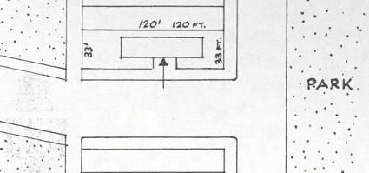
Site Plan

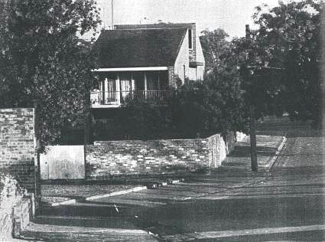
House from rear (1967)

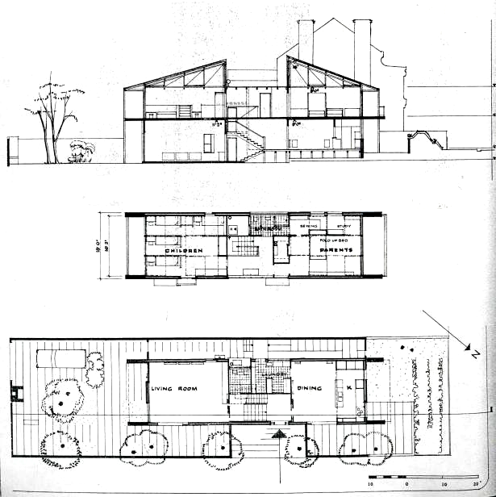
Plans and Elevations

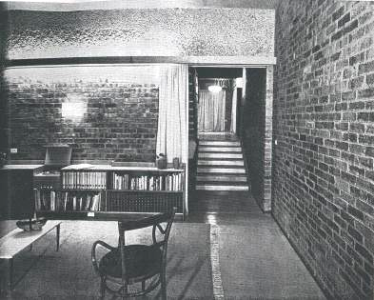

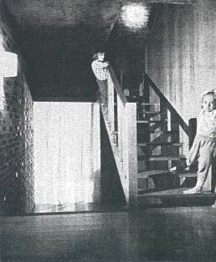

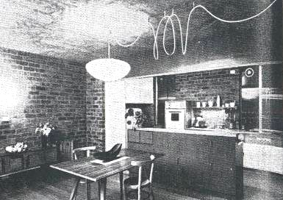
Interior (1967)

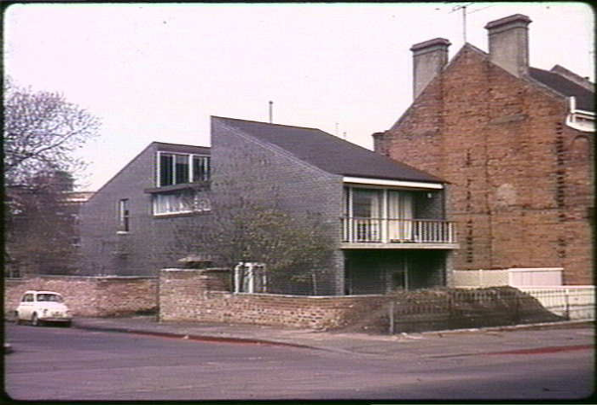
1962 : Picture Collection, State Library of Victoria, Peter Wille collection

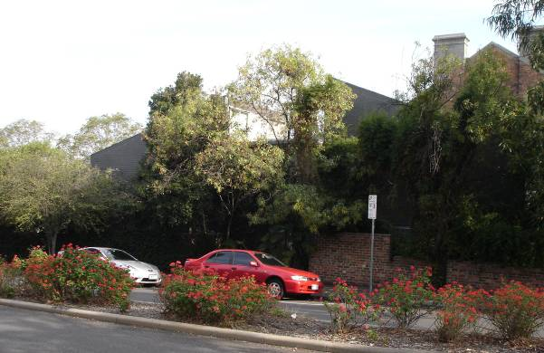
2009 Rohan Storey

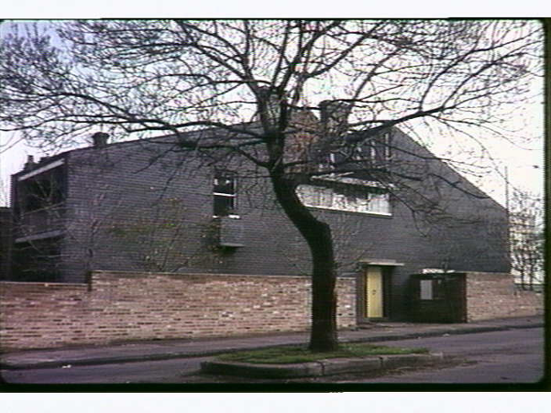1962 Source : Picture Collection, State Library of Victoria, Peter Wille collection

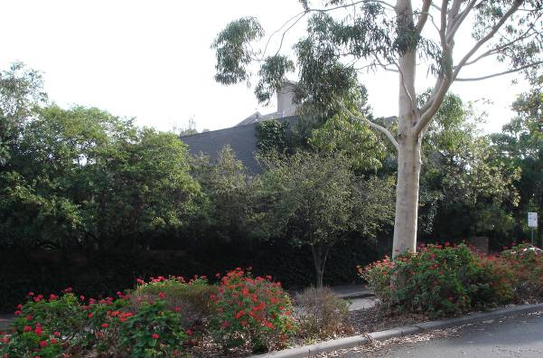2009 Rohan Storey

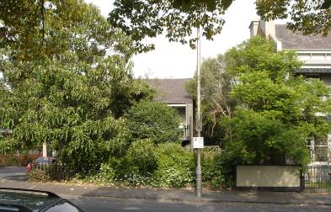
2009 Gatehouse Street frontage

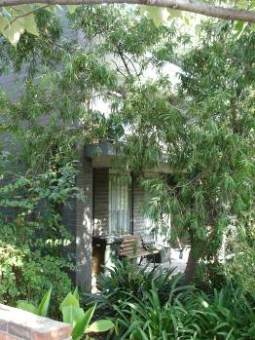
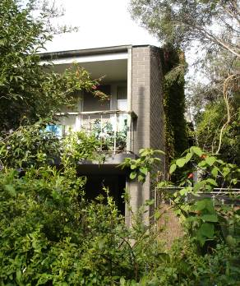

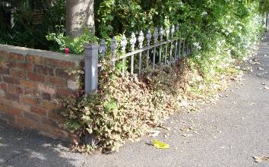

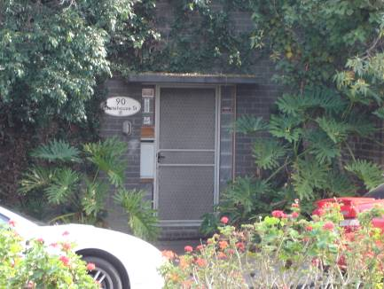
Front door, Morrah Street

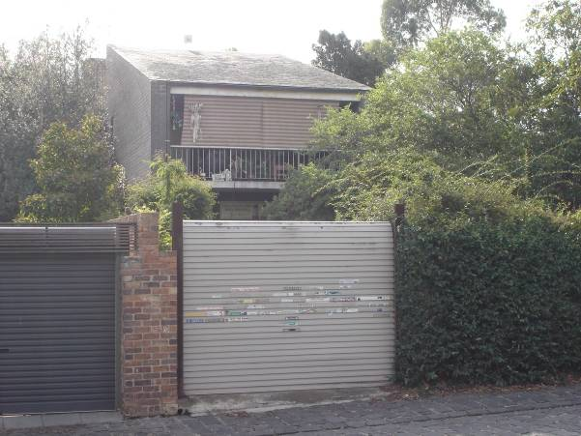Rear balcony

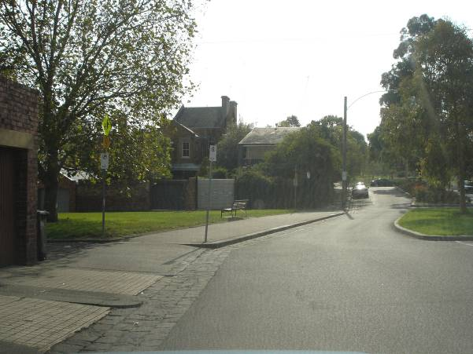House in context from rear

Comparison:
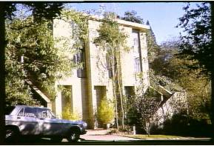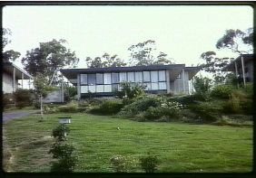
House, Gordon Grove, Sth Yarra, and house in Campbell, Canberra, both Grounds Romberg & Boyd, 1961

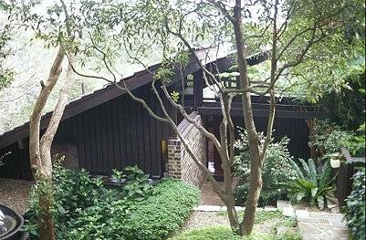
House by Ken Wooley, 33 Bullecourt Avenue Mosman, 1962
Image from sydneyarchitecture.com

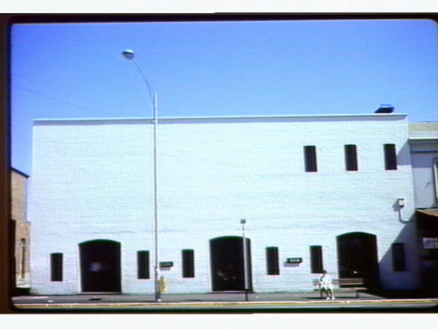
Jimmy Watson’s Tavern, Lygon Street Carlton, Robin Boyd, 1962
Image : State library of Victoria, Wille collection

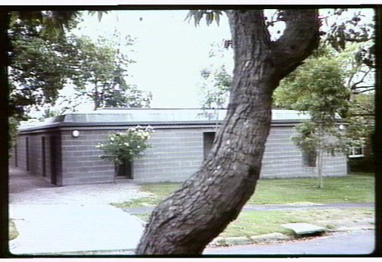

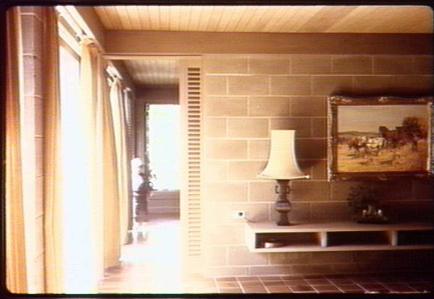
Richardson House, Brewster Street Essendon, Graeme Gunn, 1963
Images : State library of Victoria, Wille collection

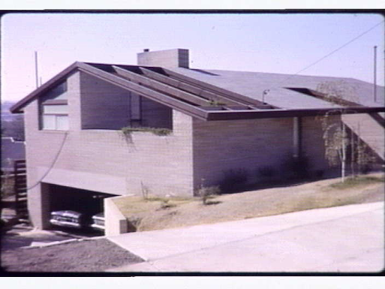
House by Neville Quarry, 5 Streeton Crescent. Heidelberg, 1965
Image : State library of Victoria, Wille collection

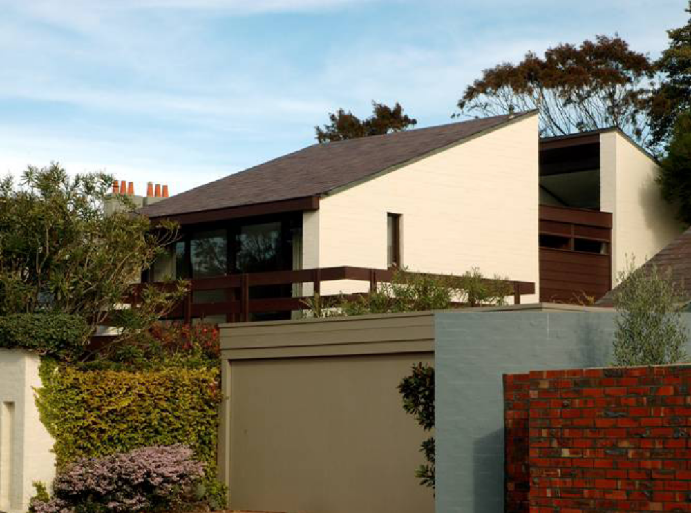
House, 5 Sandown St, Brighton, John Baird, Cuthbert & Partners, 1967
Image from ‘Bayside Heritage Trail’, 2007

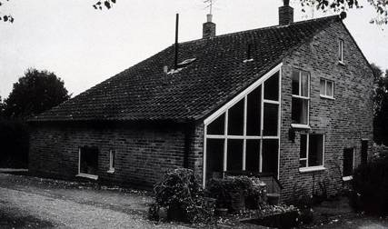

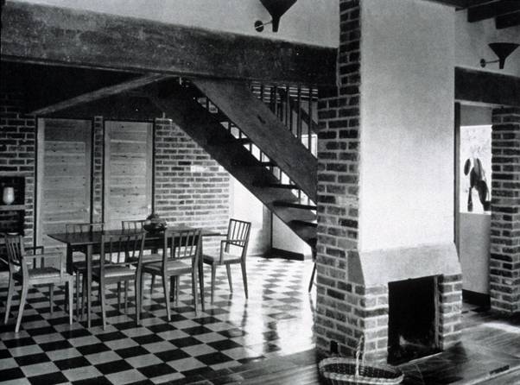
Allison and Peter Smithson, Sugden House, Watford, England, 1955-6
Image from www.mariabuszek.com (Assistant Professor of Art History, Kansas City Art Institute.)

ASSESSMENT AGAINST CRITERIA:

A Importance to the course or pattern of Victoria's cultural history

The Saunders House is important in the history of the development of architecture in Victoria. It was very unusual for its time as one of the first structures to be influenced by the relatively new English Brutalist movement in Victoria, as well as probably the first modernist post-war houses to specifically make historicist and contextual references.

B Possession of uncommon, rare or endangered aspects of Victoria's cultural history

C Potential to yield information that will contribute to an understanding of Victoria's cultural heritage

D Importance in demonstrating the principal characteristics of a class of cultural places or objects

E importance in exhibiting particular aesthetic characteristics

The Saunders House is important for exhibiting the particular characteristics associated with English Brutalist architecture, namely the use of unadorned brickwork, both inside and out, and simple forms. It is also important for responding to the form of the surrounding terrace houses, particularly through the use of the opposing pitched roofs, clad in recycled slate, but in a modernist idiom.

F Importance in demonstrating a high degree of creative or technical achievement at a particular period

G Strong or special association with a particular community or cultural group for social, cultural or spiritual reasons. This includes the significance of a place to Indigenous peoples as part of their continuing and developing cultural traditions.

H Special association with the life or works of a person, or group of persons, of importance to Victoria’s history.

The Saunders House was the self-designed family home of David Saunders, who in the decade before building the house, established himself as perhaps the first academic in Australia to investigate and teach Australian architectural history. He lived in the house for 6 years, while consolidating his interests in architectural history at the nearby School of Architecture at Melbourne University, where he became a Senior Lecturer. He also helped the then newly established National Trust in its work of identifying significant places across Victoria, editing Historic Buildings in Victoria for the Victorian National Trust in 1966. He went on to become a respected leader and innovator in the fields of architectural history and the practice of architecture and architectural education through his later positions at Sydney University and finally Adelaide University. He helped to establish the Australian branch of ICOMOS, becoming its first president in 1977, and helped to establish SAHANZ, the Society of Architectural Historians of Australia and New Zealand in 1985, a year before his death.

INTERNAL PURPOSES

OWNERSHIP (CONFIDENTIAL)
Kerri Elizabeth Beggs
90 Gatehouse Street
PARKVILLE Vic 3052

MANAGEMENT ISSUES / THREATS
Although covered by the South Parkville heritage overlay area control, the house has no specific grading, and is therefore not specifically protected.

DATE OF SUBMISSION
June 2009

PHOTOGRAPHS
Various

NAMES & ADDRESSES OF RESEARCHERS / COMPILERS / CONTRIBUTORS / NOMINATOR (CONFIDENTIAL)
Carlos Garcia-Noriega Bueno
Email: s3040508@student.rmit.edu.au
Date: 25.06.07

Rohan Storey, Staff Architectural Historian

DATE AND EXTENT OF LAST INSPECTION
May 2009, exterior only.

NAMES OF PEOPLE MAKING INSPECTIONS
Rohan Storey, Staff Architectural Historian

EXISTING DESIGNATIONS

Victorian Heritage Register - No
Register of the National Estate - No
Local ‘Heritage Overlay’ Control - part of Parkville area HO4
Local Conservation Study Level - not graded

